**Project – I Report**

**Subject Code: - 4IT31**

**House Price Prediction**

**Group Number: - G.13**

**18IT404: Man Desai**

**18IT405: Kalp Gohil**

**18IT413: Param Shah**

**17IT419: Jay Patel**

**Guided By :- Prof. Prachi Shah**

**BACHELOR OF ENGINEERING**

***In***

**INFORMATION TECHNOLOGY**



**Birla Vishvakarma Mahavidyalaya**

**Engineering College,**

**Vallabh Vidhyanagar-388120**

**1 - Introduction :**

**1.1 Motivation :**

There are lots of people making huge mistakes when buying the properties. Most of the people are buying properties from the people they do not know or by seeing the advertisements. One of the common mistakes is buying the properties that are too expensive but it is not worth it. And at the end people sum up with loss.

So our main motive here is to build a model that will help people who want to buy or sell any properties. It will help people by predicting nearest price of a house according to parameters of that house. So it will help society and also reduce human effort and at the end people will sum up with happiness.

**1.2 Main Purpose of Our Project :**

The goal to predict the price of a given house according to the market prices taking into account different “features” that will be developed in the following sections.

Main objective in this project is to obtain reasonably good to predict house prices based on some variables included in the dataset.

**2 - General Description of the System :-**

**2.1 Module Description:**

**2.1.1 Selecting Dataset.**

* + One csv file that contains information about price of a house according to some parameters.

**2.1.2 Data Processing.**

* + After having data in hand, it’s important to pre-process the data to transform raw data in a useful and efficient format.
  + **Data Cleaning:** Dataset can have many irrelevant data and missing parts. So it is required to clean data.
    - Dropping Null values.
    - Filling Null values with mean.

**2.1.3 Data Transformation.**

* + After data cleaning, need to transform data into appropriate form suitable for model training.
  + **Attribute Selection:** In this strategy, new attributes are constructed from given set of attributes to help model.
    - Aggregate function can be used on two or more columns to have new column that may have highly positive or highly negative correlation with target value.

**2.1.4 Selecting Model.**

* + Now data is all set to be trained. But How….??
  + So, it is required to select an appropriate training method to train model.
  + So, understanding relationship between various set of attributes using histograms, pie charts, bar graphs, etc can help one to select best method to train model.

**2.1.5 Display the result.**

* + One simple website has been created to deploy this model, that takes input as parameters and predict house price accordingly.
  + Django framework is used for same.

**2.2 Function of various user of the system:**

There are 2 users of the system.

1. Customer
   1. User can login or register in the system.
   2. User can give required data to predict the price of House.
2. Admin
   1. Admin have access to the database of personal details of the user.
   2. Admin can also update interface in the system.

**2.3 Feasibility Study:**

A feasibility study is used to determine the viability of an idea, such as ensuring a project is legally and technically feasible as well as economically justifiable. It tells us whether a project is worth the investment.

**2.3.1 Technical Feasibility:**

This assessment focus on technical resource required for this system is available at organization or not. All the necessary technical resource exists at the organization to do what is suggested. An organization has sufficient memory storage available to hold the data required to use this system. After

This system has been developed it can be updated, but it will require someone with technical knowledge. This system also provides security to user’s data.

**2.3.2 Operational Feasibility:**

This assessment involves undertaking a study to analyze and determine whether and how well the organization’s needs can be met by completing the project. There will be sufficient support for the end user from management.

**2.3.3 Economical Feasibility:**

This assessment typically involves a cost/ benefits study of the project, helping organizations determine the cost and benefits associated with a project before financial resources are allocated.

As this system is not considered for a business purpose, no any pre-investment is required and also no any benefits has been calculated.

**2.3.4 Legal Feasibility:**

This assessment investigates whether any aspect of the proposed system conflicts with legal acts.

As this system is not considered for a business purpose, so that all the constraints that has to be followed by an respected organization while developing such system will not be hindrance for developer.

**3 - Interface Requirements**

**3.1 Hardware Interface**

* Computer
* Local Server, etc

**3.1 Software Interface**

* Python Language
* Basic of some libraries
* Django Framework
* GitHub

**4 - SRS Diagrams**

**4.1 Data Flow Diagram**

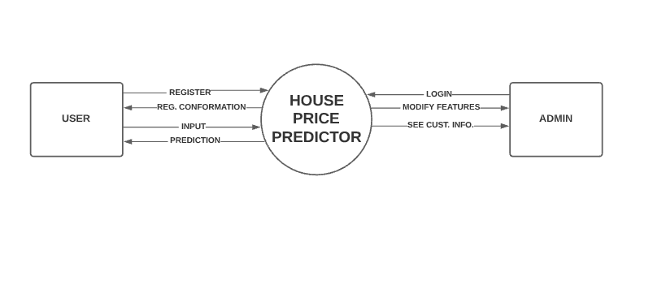

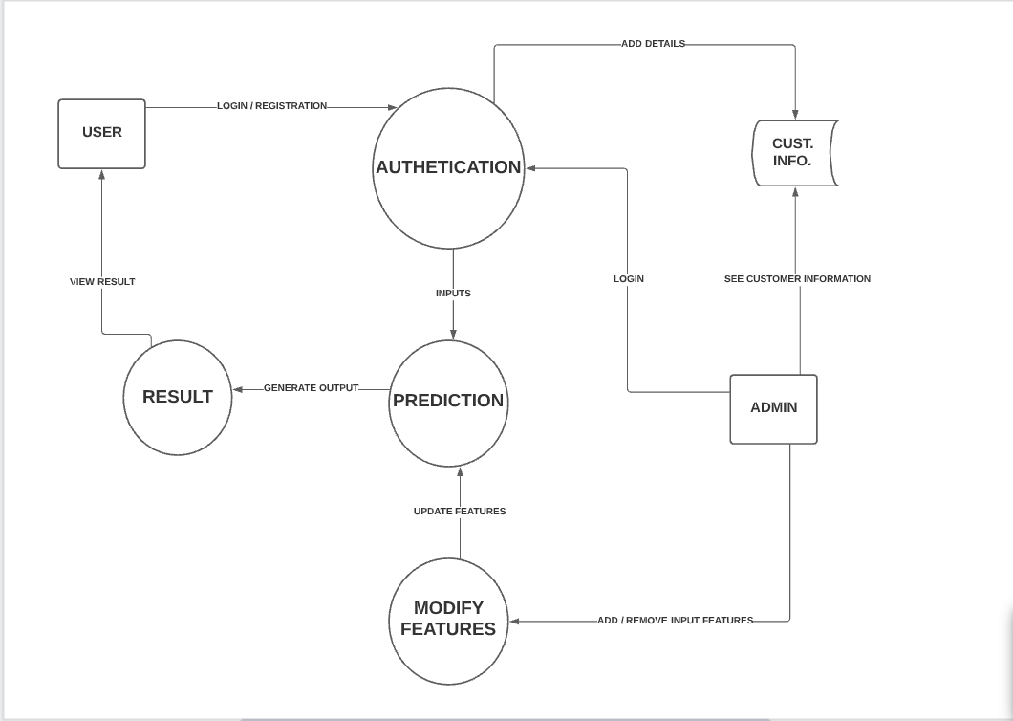

**4.2 Use Case Diagram**

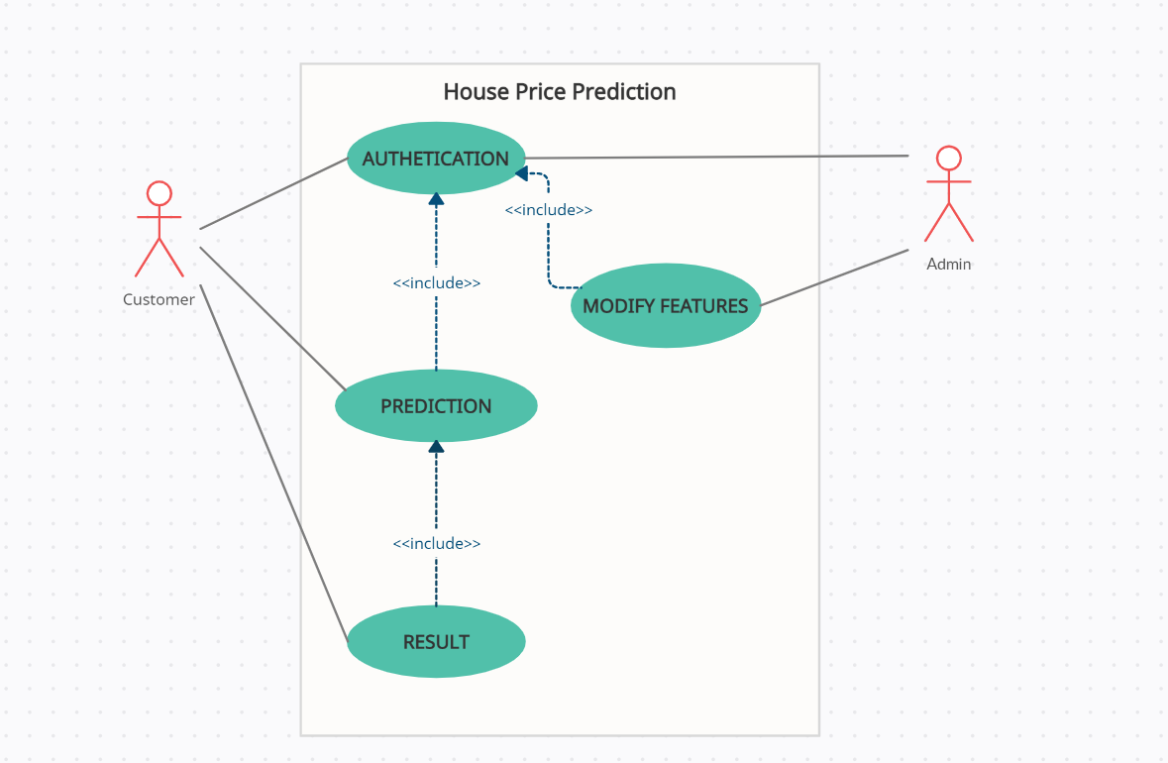

**4.3 Sequence Diagram**

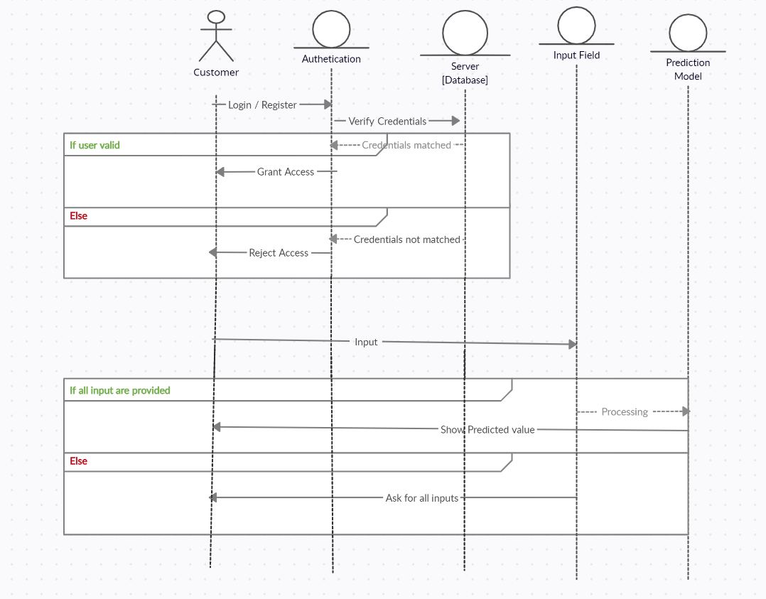

**4.4 Model View**

